ADVANCED CLASSROOM EXPERTISE TEACHER RECOGNITION
PORTFOLIO FORM FOR THE 2018 PROCESS

Portfolio Form

Closes on 6 August 2018

If you have been invited to submit a portfolio for consideration as an Advanced Classroom Expertise Teacher (ACET) you need to complete this Portfolio Form, along with your supporting body of evidence, and post it to the ACET recognition team no later than 6 August 2018.
You can save this form to your computer and continue to work on it electronically before printing and signing it.
A portfolio comprises both the Portfolio Form and a supporting body of evidence. Your portfolio must be certified by your principal as an accurate representation of your classroom and professional practice. Your principal must also make a recommendation on the basis of your portfolio. Portfolios without a recommendation will not be accepted.
This Portfolio Form must also be signed by you.
Please refer to the Portfolio Guide for Teachers when completing your portfolio. It contains information about ACET recognition, submitting a portfolio and the format of your supporting body of evidence. You can download the guide from www.TeachNZ.govt.nz/ACET.
If you have any questions, refer to the Portfolio Frequently Asked Questions available at www.TeachNZ.govt.nz/ACET. You can contact the ACET recognition team at TeachNZ by calling 0800 165 225 or emailing ACET.Recognition@
education.govt.nz.
Your TeachNZ ID is needed for this form. It was included in our email to you on 26 March 2018 inviting you to submit a portfolio. If you are unable to locate it, please contact us.
It is important to ensure that you have fully completed your Portfolio Form. Mandatory fields are indicated by an
asterisk (*).

Contact details |  | Sending the portfolio
 |  | Please print your completed form and return by courier or post.
TeachNZ ID:* |  | Return by courier to:  ACET Recognition  Ministry of Education  Level 5, 33 Bowen Street  Wellington 6011 | Return by post to:  ACET Recognition  Ministry of Education  PO Box 1666  Wellington 6140
First name(s):*
Middle name(s):
Last name(s):*
Preferred name:

Does your supporting body of evidence require evaluation by a panellist with te reo Māori fluency? Yes No

Principal’s certification
and recommendation
Please note: all sections of the principal certification and recommendation must be completed and signed by the principal or acting principal.

Select one of the following options:*
I certify that the following portfolio is an accurate representation of the teacher’s classroom and
professional practice.
I do not certify that the following portfolio is an accurate representation of the teacher’s classroom and
professional practice.
Select one of the following options:*
I recommend that the teacher be recognised as an Advanced Classroom Expertise Teacher.
I do not recommend that the teacher be recognised as an Advanced Classroom Expertise Teacher.
If you are not recommending that the teacher be recognised, please indicate which of the sections you
feel they do not meet and provide a brief explanation.
Section A: Overall impact on student learning outcomes
Section B: Professional practice
Section C: Engagement
Section D: Peer leadership
Section E: Professional learning
Principal’s name:*
Principal’s signature:* |  | Date:*
If you would like to be notified of the outcome of this portfolio, enter your email address below.

Privacy
The personal information in this Portfolio Form is being collected for the consideration of portfolios by the evaluation panel for research and statistical purposes and, should the teacher be selected, for the administration of the ACET allowance.
The personal information collected may be used by the Ministry of Education (the Ministry) and disclosed to other parts of the Ministry and agencies such as your school. The personal information will be held by the Ministry, and you have the right to access and request corrections to your information. The information provided by NZEI Te Riu Roa members may be disclosed to NZEI Te Riu Roa in accordance with the consent given by members when they join the union.
The information about your classroom and professional practice in this Portfolio Form and supporting body of evidence is being collected solely for the purposes of consideration
of portfolios by the evaluation panel and for the administration of the ACET process by the Secretariat.

Third person privacy
To protect the privacy of third parties such as students,
you need to ensure that you remove any unique identifying information (such as surnames) from your supporting body
of evidence.

Teacher’s declaration
Read each statement and tick if it is true, then sign and date below. If you cannot truthfully tick each statement, do not sign or send this form.
I certify that the information given is true and accurate.
I have read and understood the Portfolio Guide
for Teachers.
I agree to the Terms of the Allowance on page 4 of the Portfolio Guide for Teachers.
No material included in my portfolio enables the identification of an individual.
Teacher’s name:*
Teacher’s signature:* |  | Date:*
Checklist
Principal’s certification: My principal or acting principal
has certified my portfolio.
Principal’s recommendation: My principal or acting principal has made a recommendation and signed and dated this form.
Teacher’s declaration: I have ticked the boxes and signed and dated this form.
Supporting body of evidence: Digital evidence is in one of the accepted file formats. Refer to page 2 of the Portfolio Guide for Teachers.
Return my portfolio in the enclosed courier bag.

Section A: Overall impact on student learning outcomes
This section provides an opportunity for you to describe how the various areas of your professional practice and knowledge contribute to positive student outcomes.
Describe how your overall professional practice has led to positive social, cultural and academic outcomes for diverse (all) students, taking account of the following matters (which are separately further detailed in the Sections below):..
- professional practice (criterion 3a)
- engagement (criterion 3b)
- peer leadership (criterion 3c)
- professional learning (criterion 3d).
Related criteria and evidence required in order of direct relevance
ACET criterion 2:  Explicitly demonstrating positive outcomes for all learners, with specific information about meeting the needs of students identified as ‘priority learners’  in Government policy. | Evidence supporting your description  of positive learning outcomes for all students in relation to the New Zealand Curriculum or Te Marautanga o Aotearoa or other relevant official curriculum documents.  Evidence should include:  - an overview of a selected area or areas of your planning, teaching practice and assessment judgments that show how you have (a) identified student needs, (b) designed and implemented a teaching programme to meet those needs, and (c) tracked and analysed student progress through a teaching-as-inquiry cycle  - attestation and/or appraisal documentation and/or parental feedback and/or principal or teaching colleague feedback that supports this.
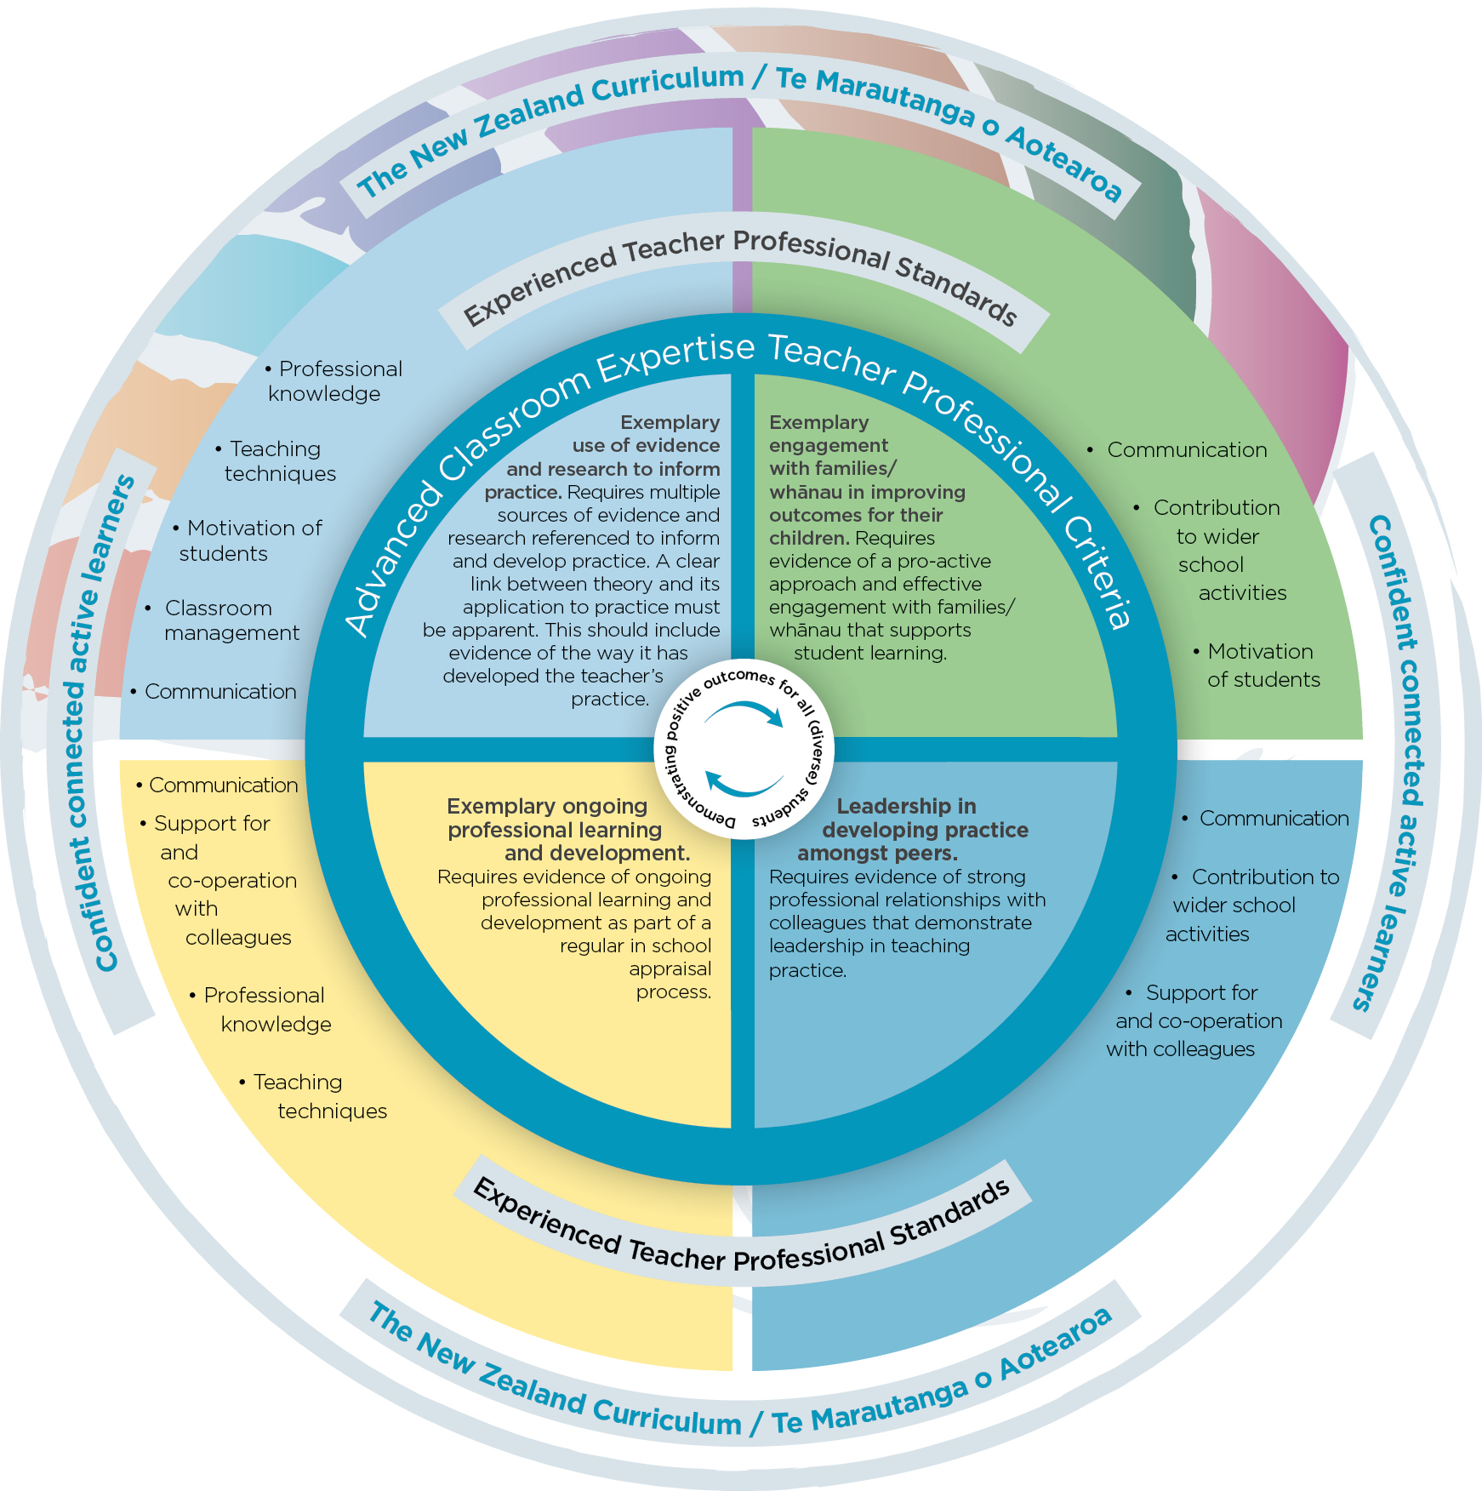
Please refer to page 6 of the Portfolio Guide for Teachers.

Complete electronically. Word limit – 1,000
Insert rows in table below as required.
Evidence reference number | Title of evidence | Brief description of evidence

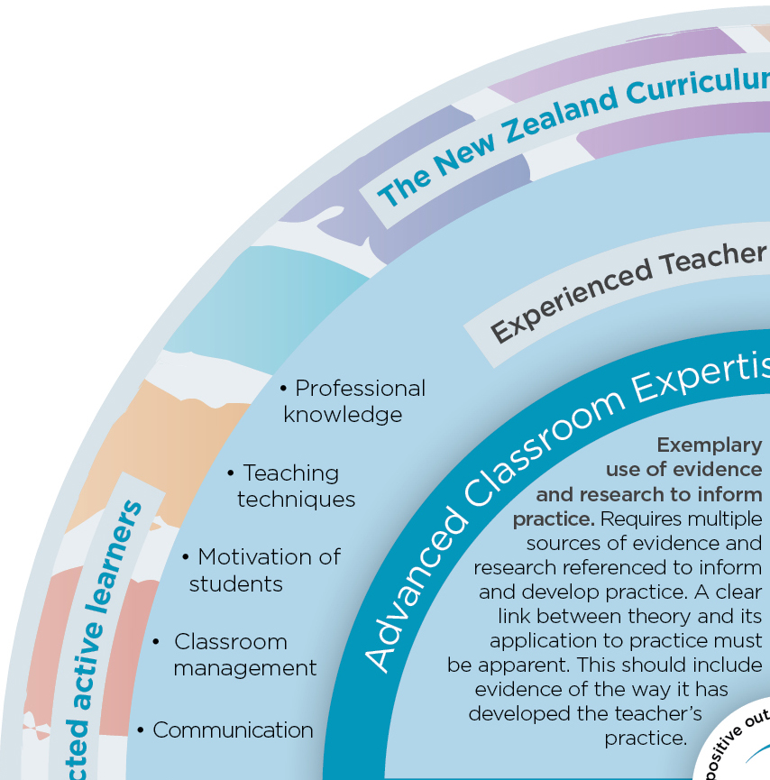
Section B: Professional practice (criterion 3a)
Demonstrate how your exemplary use of evidence and research to inform professional practice has led to positive outcomes for diverse (all) students.
Related criteria and evidence required in order of direct relevance
ACET criterion 3a:  Exemplary use of evidence and research to inform practice. | Requires multiple sources of evidence and its application to practice. This should include evidence of the ways that theory, research, professional learning and development have informed practice.  A list of references to research that has informed your professional practice should be provided.
ACET criterion 1:  Practice demonstrably higher than the Experienced Teacher Professional Standards. | Evidence is needed of practice that demonstrates creativity and innovation with ongoing development built on an evidential base from both research and academic theory, and sound analysis  of children’s learning:  - professional knowledge.  - teaching techniques.  - motivation of students.  - classroom management.  - communication.
ACET criterion 2:  Explicitly demonstrating positive outcomes for all learners, with specific information about meeting the needs of students identified as ‘priority learners’ in Government policy. | Evidence is needed of positive student learning outcomes for all learners related to the New Zealand Curriculum or Te Marautanga o Aotearoa or other relevant official curriculum documents through taking account of, and planning for the learning needs of all children.
Please refer to page 7 of the Portfolio Guide for Teachers.

Complete electronically. Word limit – 500
Insert rows in table below as required.
Evidence reference number | Title of evidence | Brief description of evidence

Section C: Engagement (criterion 3b)
Demonstrate how your exemplary engagement with families/whānau has led to positive outcomes for diverse (all) students.
Related criteria and evidence required in order of direct relevance
ACET criterion 3b:  Exemplary engagement with families/whānau in improving outcomes for their children. | Requires evidence of a proactive dialogue and engagement with families/whānau that supports student learning.
ACET criterion 1:  Practice demonstrably higher than the Experienced Teacher Professional Standards. | Evidence is needed of practice  that demonstrates creativity, forms partnerships and demonstrates innovation with ongoing development built on an evidential base from both research and academic theory, and sound analysis of children’s learning:  - communication.  - contribution to wider school activities.  - motivation of students.
ACET criterion 2:  Explicitly demonstrating positive outcomes for all learners, with specific information about meeting the needs of students identified as ‘priority learners’ in Government policy. | Positive social, cultural and academic outcomes for priority learners.  Evidence is needed of positive student learning outcomes for all learners related to the New Zealand Curriculum or Te Marautanga o Aotearoa or other relevant official curriculum documents through taking account of, and planning for the learning needs of all children.
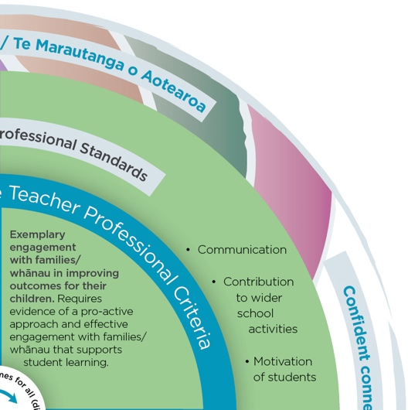
Please refer to page 8 of the Portfolio Guide for Teachers.

Complete electronically. Word limit – 500
Insert rows in table below as required.
Evidence reference number | Title of evidence | Brief description of evidence

Section D: Peer leadership (criterion 3c)
Demonstrate leadership in developing practice amongst peers that has led to positive outcomes for diverse (all) students.
Related criteria and evidence required in order of direct relevance
ACET criterion 3c:  Leadership in developing practice  among peers. | Requires evidence of strong professional relationships with colleagues that demonstrate leadership in teaching practice.
ACET criterion 1:  Practice demonstrably higher than the Experienced Teacher Professional Standards. | Evidence is needed of practice that demonstrates creativity and innovation with ongoing development built on an evidential base from both research and academic theory, and sound analysis  of children’s learning:  - communication.  - contribution to wider school activities.  - support for and co-operation with colleagues.
ACET criterion 2:  Explicitly demonstrating positive outcomes for all learners, with specific information about meeting the needs of students identified as ‘priority learners’ in Government policy. | Evidence is needed of positive student learning outcomes for all learners related to the New Zealand Curriculum or Te Marautanga o Aotearoa or other relevant official curriculum documents through taking account of, and planning for the learning needs of all children.
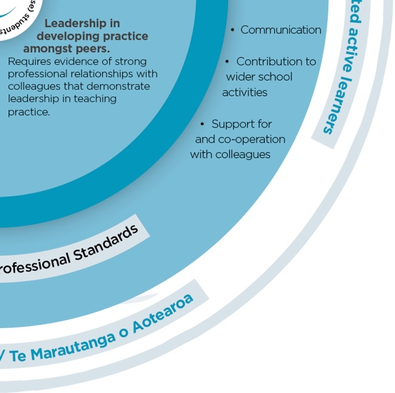
Please refer to page 9 of the Portfolio Guide for Teachers.

Complete electronically. Word limit – 500
Insert rows in table below as required.
Evidence reference number | Title of evidence | Brief description of evidence

Section E: Professional learning and development (criterion 3d)
Demonstrate how your ongoing professional learning and development has led to positive outcomes for diverse (all) students.
Related criteria and evidence required in order of direct relevance
ACET criterion 3d:  Exemplary ongoing professional learning and development. | Requires evidence of ongoing professional learning and development  as part of a regular in school appraisal process.
ACET criterion 1:  Practice demonstrably higher than the Experienced Teacher Professional Standards. | Evidence is needed of practice that demonstrates creativity and innovation with ongoing development built on an evidential base from both research and academic theory, and sound analysis  of children’s learning:  - professional knowledge.  - teaching techniques.  - support for and co-operation with colleagues.  - communication.
ACET criterion 2:  Explicitly demonstrating positive outcomes for all learners, with specific information about meeting the needs of students identified as ‘priority learners’  in Government policy. | Evidence is needed of positive student learning outcomes for all learners related to the New Zealand Curriculum or Te Marautanga o Aotearoa or other relevant official curriculum documents through taking account of, and planning for the learning needs of all children.
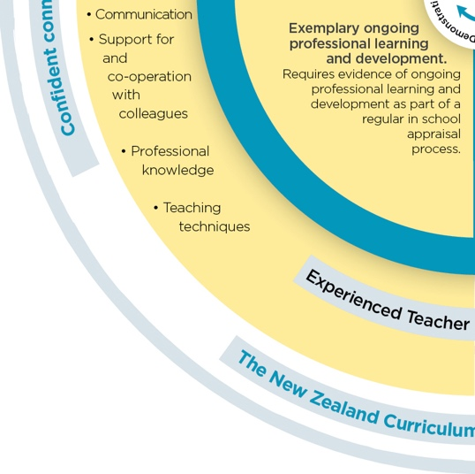
Please refer to page 10 of the Portfolio Guide for Teachers.
Please complete electronically. Word limit – 500
Insert rows in table below as required.
Evidence reference number | Title of evidence | Brief description of evidence

